

***DATA ENGINEERING***

***WEEK-02***

***TASK-08***

*Submitted to*

***Sir Muhammad Ahtisham***

*Submitted by*

***Aabra Malik***

***Creating Table***

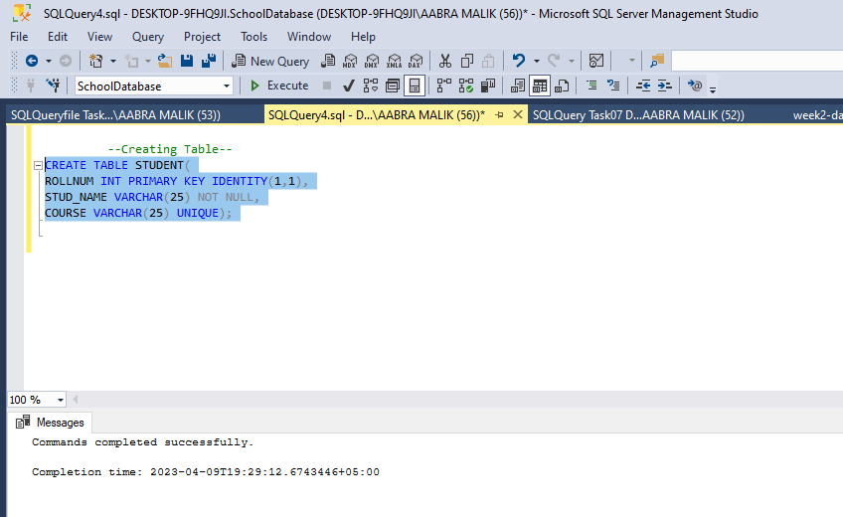

***Inserting Multiple Rows using single insert Statement***

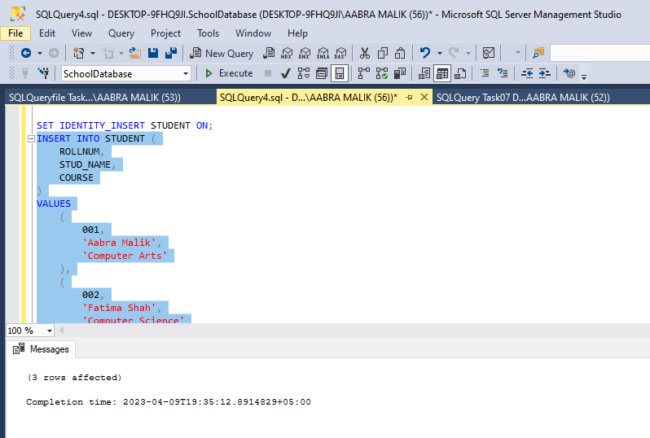

***Viewing Records***

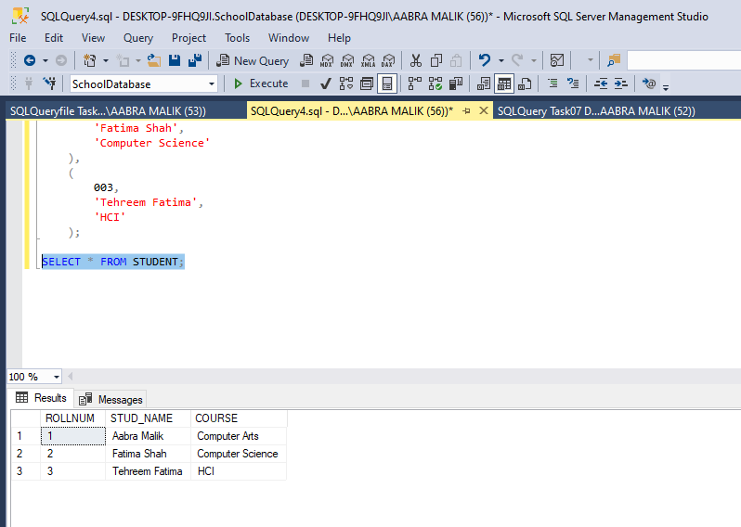

***deleting rows from a table having certain values certain value***

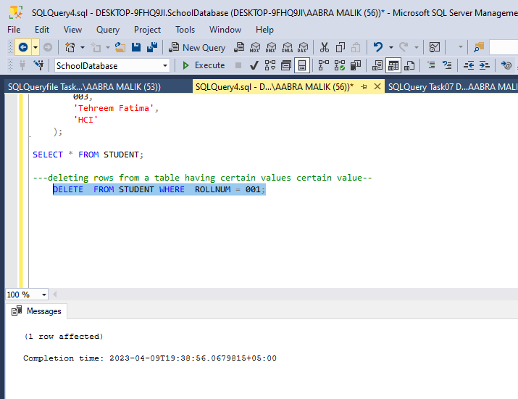

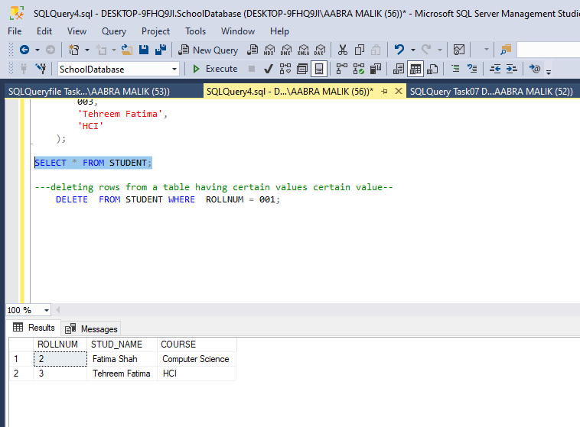

***Updating Records***



